Lecture 3 – Wound Healing

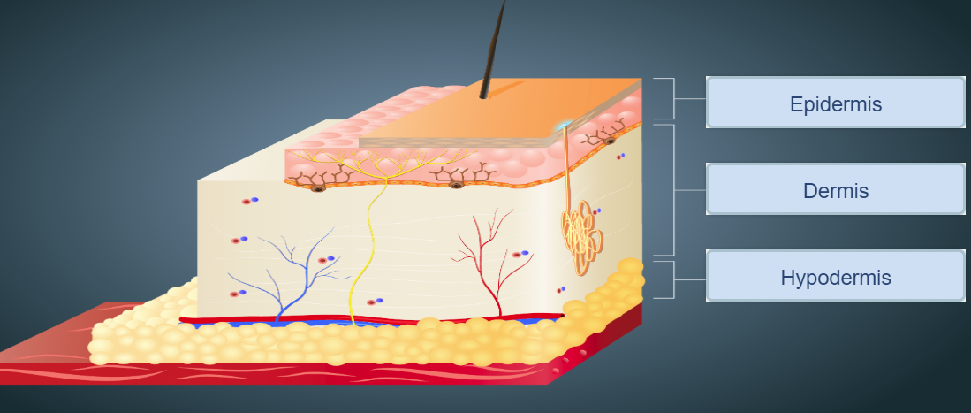Skin Anatomy

* Epidermis (outermost layer of skin)
  + Rich in tough protein called keratin, and containing two main types of cells:
    - Keratinocytes, barrier against environmental damage
    - Melanocytes, produces a pigment, melanin, responsible for skin color and protection of UV radiation
  + Forms waterproof barrier between body and external environment
    - Resists friction
    - Resists microbial invasion
    - Prevents water loss from body
  + Doesn’t carry blood vessels, but receives nourishment from capillaries in dermis
  + As cells of the outer surface of epidermis are shed, cells from the stratum basale (bottom layer of epidermis) divide and replenish the epidermis
* Dermis (beneath the epidermis)
  + Contains all blood vessels and most nerve tissue from skin
  + Responsible for:
    - Elasticity and strength of skin
    - supplier of nutrients for epidermis
    - Important for thermoregulation, regulate internal body temperature
  + Contains two fibres:
    - Collagen fibres, provides skin with tensile strength and resistance to stretching forces
    - Elastic fibres provide its recoil properties
  + Composed of numerous cell types:
    - Fibroblasts
    - Immune cells, eg. Macrophages
    - Adipocytes, cells that store energy as fat
  + Divide into two sub-layers:
    - Papillary region composed of areolar connective tissue
      * Formed by protrusions of dermis into epidermis
      * Interior of protrusion supply epidermis with oxygen and nutrients
      * Contains tactile receptors, known as Meissner’s Corpuscles (responsible for sensitivity to light touch)
    - Reticular region composed of dense connective tissue of thick bundles of collagen fibres
      * Contains: roots of hairs, sebaceous glands (secretes oil to lubricate skin and hair), sweat glands, receptors, nails, nerve endings and blood vessels
* Hypodermis (aka. Subcutaneous layer) lies below dermis
  + Lies below dermis
  + Connective tissue containing fat (adipose tissue: energy reserve, insulate body and cushion to protect underlying structures from trauma), blood vessels and sensory receptors
  + Functions as a protective cushion and insulator
* Muscle layer lies below hypodermis

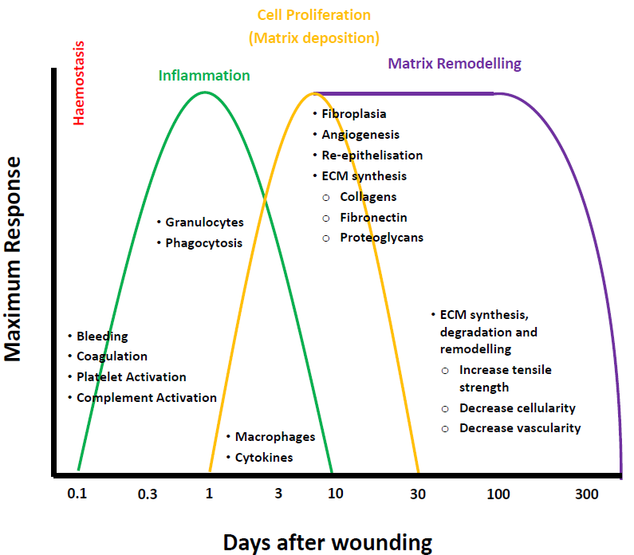Four main phases of a wound

* Haemostasis (causes wound to stop bleeding)
  + When cut $→$ capillaries torn $→$ bleeding
  + Injury to microvasculature (smallest systems of blood vessels in body) $→$ constriction of blood vessels
  + Coagulation cascade activated, to stop bleeding
    - Blood clotting begins to prevent blood loss and protect against viruses or bacteria
    - Platelets bind directly to collagen (protein in muscles, bones, skin, blood vessels, etc.)
    - Von Willebrand Factor (WWF) by forming additional links between platelets and collagen ( $↑$ strength)
    - Proteins formed:
      * Fibrin is an insoluble protein forms fibrous mesh and acts as a “glue” to bind platelets to each other to stop blood flow
      * Fibronectin is a glycoprotein (carbohydrate grouped protein) that anchors cells to collagen
      * Vitronectin is a glycoprotein that regulates coagulation cascade
  + Platelets release growth factors
    - Initiation of the wound healing
    - Attract and activate:
      * Fibroblasts is a biological cell combines the extracellular matrix and collagen to produce a structural framework for animal tissue to form (connective tissues)
      * Endothelial cells line inside of blood vessel to carry excess blood plasma around the body
      * Macrophages is a large white blood cell is to locate microscopic foreign bodies and eat them
* Inflammatory
  + Early Stage
    - Infiltration of inflammatory cells, due to the increased blood flow as tissue becomes reddened and swollen
      * Granulocytes is a white blood cell that has granules with enzymes to be released during infections
      * Polymorphonuclear leukocytes is a white blood cells released during infections, allergic reactions, and asthma
    - Phagocytosis is the removal of bacteria and foreign materials by phagocytes
    - Prevents infection
  + Late Stage
    - Monocytes (white blood cells) are attracted to wound area, such as macrophages
      * Growth factor and other effects on other cells release
      * Recruit fibroblasts, keratinocytes (an epidermal cell producing a fibrous protein), endothelial cells
      * Proteases, breaks down enzymes molecules as they go through tissue remodeling
* Cell Proliferation (Extra Cellular Matrix deposition)
  + Wound begins to heal
  + Migrations of fibroblasts $→$ proliferation of fibroblasts
    - Start to produce ECM proteins (mostly found in the skin) which make up the dermis
      * Fibronectin
      * Collagen (enzyme protein) gives the skin the plumpness
      * Proteoglycans
      * Elastin gives the skin elasticity (comparing between teen to old)
  + Collagen synthesis
    - Provides strength and structure to the dermis
  + Angiogenesis is the formation of blood vessels from pre-existing ones
    - Big wound $→$ blood vessels need to be replaced (within 200 microns) $→$ Angiogenesis causes the blood to be replaced for nutrients to be applied, so wound can heal
    - Macrophages release angiogenic factors to switch on and produce new blood vessels
  + Granulation tissue formation
    - Capillaries
    - Proliferating fibroblasts
    - Macrophages
    - Collagen
    - Glycoproteins
  + Epithelisation
    - Reformation of the epidermis
      * Migration of keratinocytes across the top of the dermis (wound)
* Matrix Remodelling (Regeneration)
  + Cells deposit matrix while remodeling the tissue, simultaneously
  + Occurs over prolonged time periods depending on the size of the injury
  + Breakdown and remodeling of ECM proteins, including collagen
  + As time passes, process slows down as wound is fully healed

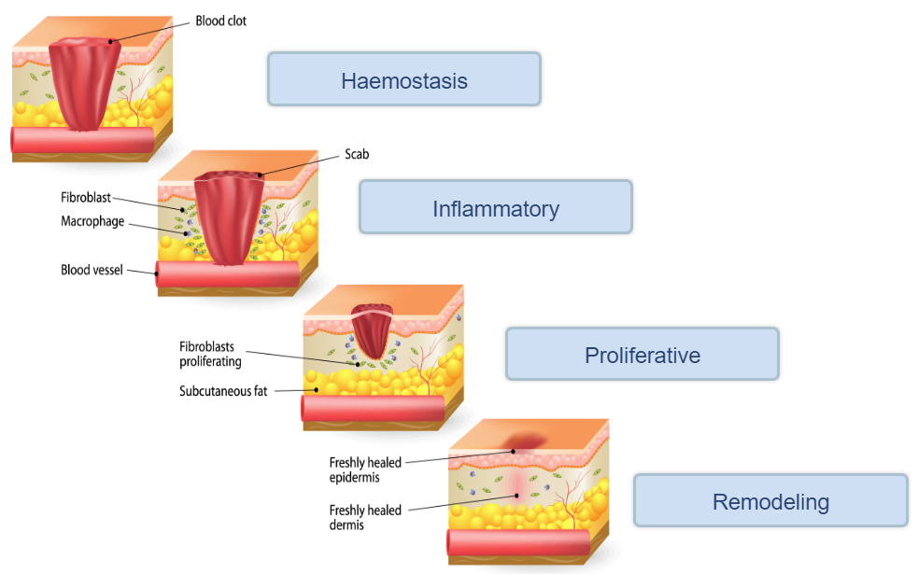

Abnormal Wound Healing

* Hypertrophic scar (Hyper $→$ increasing)
  + Confined to the border of original wound
  + Reduce in size over time
  + Use of collagen (from fibroblasts)
* Keloid scar
  + 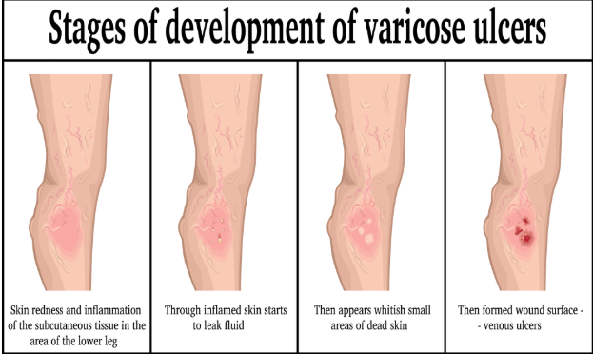Genetic issue, so when removed, it can come back
  + Extend beyond the border of the wound (overgrowth of scar tissue)
  + Will not reduce over time
  + Thick collagen (excess collagen provided)

Chronic Wound

* Venous Ulcer
  + Non-functioning of venous valves, usually of the legs
    - insufficient blood flow
    - 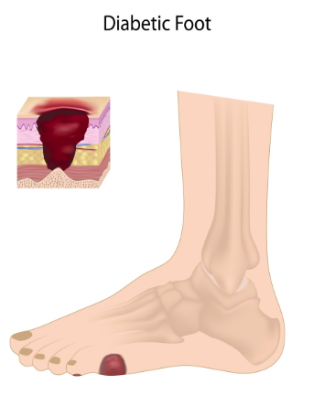build-up of inflammatory cells
    - insufficient removal of waste produced by inflammatory cells
* Diabetic Ulcer
  + Normally diabetes type 2 and seen on foot
  + Pathologies that are associated with diabetic patients
    - Peripheral neuropathy – form of nerve damage, causing patient not to realize wound $→$ delayed wound care
    - Peripheral arterial disease – similar to venous ulcer $→$ limited blood flow causing build-up of inflammatory cells and waste
    - Infection – puts diabetic patients at a greater risk of wounds $→$ worsen wounds and may require amputation
* Pressure Ulcer
  + 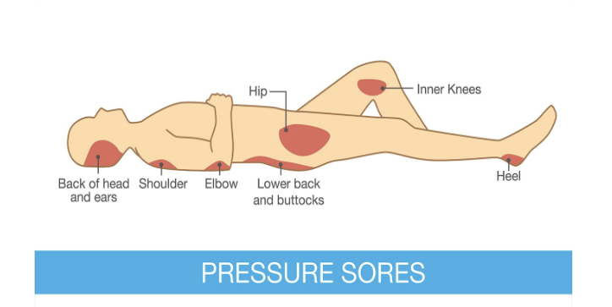Commonly caused by restricted blood flow or absence of blood flow to region
    - Found in limited mobile patients and patients being in same position with increased pressure for a long period of time

Treatment of Chronic Wounds

* Problems
  + Heterogeneous – all cases are different $→$ different measures to be accounted for
  + Underlying conditions – genetic symptoms/problems pre-existing before the problem
  + Age – elderly
* Common courses of treatment
  + Debridement is removing damaged tissues or foreign objects from wound
  + Dressing
    - Sterile pad or compression
    - Promote healing and protection from further harm
  + Compression/pressure bandages, negative pressure therapy
    - Compression bandages used to control fluids exerted from wound and reduce swelling in region
    - Pressure bandages compresses dead space and prevents blood clotting and blood plasma formation
    - Negative pressure therapy uses a vacuum dressing to promote and enhance healing in acute or chronic wounds, and 2nd or 3rd degree burns
  + Skin grafts
    - Taking healthy skin to be transplanted to a new site on patient’s body
    - Fixes original wound, while making another wound